`

PROJECT: **TCP Chat Room Using Socket programming**

Computer Communication Network

Department of ECE

PES University Bangalore

Faculty in charge: Prof.Prajeesha

**Team Members :**

Jacob V Sanoj [PES1UG20EC083]

Kaushik Narayan [PES1UG20EC093]

Meghana M [PES1UG20EC114]

**Sem:** 5th sem

**Section:** B

| Sl no | Description | Page no |
| --- | --- | --- |
| 1. | Problem Statement |  |
| 2. | Introduction |  |
| 3. | Procedure |  |
| 4. | Code |  |
| 5. | Result |  |
| 6. | Conclusion |  |
| 7. | References |  |

**INTRODUCTION**

Chat room is a space for people across the globe to communicate with each other about various topics. The topics can range from anything such as app development to any recipes made in the kitchen. Chat rooms are great platforms for learning how to communicate.

**SOCKET PROGRAMMING**

A socket is a communications connection point (endpoint) that you can name and address in a network. Socket programming shows how to use socket APIs to establish communication links between remote and local processes.

The processes that use a socket can reside on the same system or different systems on different networks. Sockets are useful for both stand-alone and network applications. Sockets allow you to exchange information between processes on the same machine or across a network, distribute work to the most efficient machine, and they easily allow access to centralised data. Socket application program interfaces (APIs) are the network standard for TCP/IP.

The type of sockets that are most suitable are **TCP sockets** as the TransmissionControl Protocol (TCP):

* **Is reliable:** packets dropped in the network are detected and retransmitted by the sender.
* **Has in-order data delivery:** data is read by your application in the order it was written by the sender.

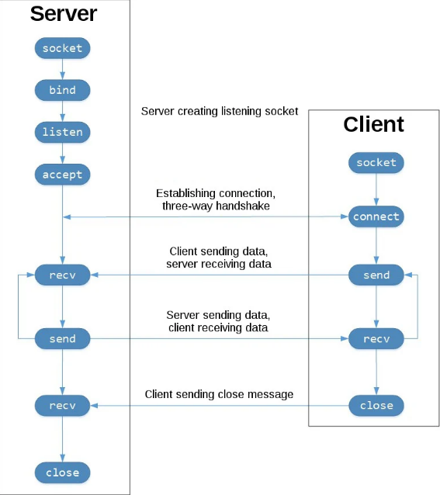

**Procedure**

## **Implementing The Server**

Now let’s start by implementing the server first. For this we will need to import two libraries, namely socket and threading. The first one will be used for the network connection and the second one is necessary for performing various tasks at the same time.

*import* threading

*import* socket

The next task is to define our connection data and to initialise our socket. We used the localhost address (127.0.0.1) and the port 55555. The port is actually irrelevant but you have to make sure that the port you are using is free and not reserved. If you are running this script on an actual server, specify the IP-address of the server as the host.

host = '127.0.0.1' # *localhost*

port = 55555

server = socket.socket(socket.AF_INET, socket.SOCK_STREAM)

server.bind((host, port))

server.listen()

clients = []

nicknames = []

When we define our socket, we need to pass two parameters. These define the type of socket we want to use.

**AF_INET** indicates that we are using an internet socket rather than an unix socket. The second parameter stands for the protocol we want to use.

**SOCK_STREAM** indicates that we are using TCP and not UDP.

After defining the socket, we bind it to our host and the specified port by passing a tuple that contains both values. We then put our server into listening mode, so that it waits for clients to connect. At the end we create two empty lists, which we will use to store the connected clients and their nicknames later on.

def *broadcast*(message): # *broadcast message to all clients connected to the server*

*for* client *in* clients:

client.send(message)

We define a function to send a message to each client that is connected and therefore in the clients list.

The following function will be responsible for handling messages from the clients.

def *handle*(client):

*while* True:

*try*:

message = client.recv(1024) # *receive message from the client at a rate of 1024 bytes*

broadcast(message) #*Try to receive message from the client and broadcast it to all other clients*

*except*:

index = clients.index(client)

clients.remove(client)

client.close()

nickname = nicknames[index]

broadcast(f'{nickname} left the chat!'.encode('ascii')) #*Any error in broadcasting message will result in the client being removed from the list*

nicknames.remove(nickname)

*break*

The function is running in a while-loop. The function accepts a client as a parameter. Everytime a client connects to our server we run this function for it and it starts an endless loop.

It receives a message from the client and broadcasts it to all connected clients.

Now if for some reason there is an error with the connection to this client, we remove it and its nickname, close the connection and broadcast that this client has left the chat. After that we break the loop and this thread comes to an end.

def *receive*():

*while* True:

client, address = server.accept() #*Accept connection*

print(f"Connected with {str(address)}")

client.send('NICK'.encode('ascii')) #*Send nickname to the client*

nickname = client.recv(1024).decode('ascii') #*Receive nickname from the client*

nicknames.append(nickname)

clients.append(client)

print(f"Nickname of the client is {nickname}!")

broadcast(f"{nickname} joined the chat!".encode('ascii')) #*Broadcast nickname to all other clients that the client with that nickname has joined the chat*

client.send('Connected to the server!'.encode('ascii'))

thread = threading.Thread(target=handle, args=(client,)) # *Each client will have its own thread*

thread.start()

When we are ready to run our server, we will execute this receive function. It also starts an endless while-loop which constantly accepts new connections from clients.

Once a client is connected it sends the string ‘NICK’ to it, which will tell the client that its nickname is requested.

After that it waits for a response (which hopefully contains the nickname) and appends the client with the respective nickname to the lists.

After that, we print and broadcast this information.

Finally, we start a new thread that runs the previously implemented handling function for this particular client.

print("Server is listening...")

receive()

## **Implementing The Client**

We shall import the same libraries as we did for the server for the client.

*import* socket

*import* threading

The first steps of the client are to choose a nickname and to connect to our server. We will need to know the exact address and the port at which our server is running.

nickname = input("Choose your nickname: ")

client = socket.socket(socket.AF_INET, socket.SOCK_STREAM)

client.connect(('127.0.0.1',55555))

Here we connect to an existing server. A client needs to have two threads that are running at the same time.

The first one will constantly receive data from the server.

The second one will send our own messages to the server.

Below is the receive function of the client.

def *receive*():

*while* True:

*try*:

message = client.recv(1024).decode('ascii') #*Receive message from the server*

*if* message == 'NICK':

client.send(nickname.encode('ascii')) #*Send nickname to the server*

*else*:

print(message)

*except*:

print("An error occured!")

client.close()

*break*

It constantly tries to receive messages and to print them onto the screen using an infinite while loop. If the message is ‘NICK’ however, it doesn’t print it but it sends its nickname to the server. In case there is some error, we close the connection and break the loop.

def *write*():

*while* True:

message = f'{nickname}: {input("")}' # *Define message to be sent to the server*

client.send(message.encode('ascii')) #*Send message to the server*

The writing function is quite a short one. It also runs in an endless loop which is always waiting for input from the user. Once it gets some, it combines it with the nickname and sends it to the server. Now we create 2 threads.

One thread is to run the receive function on an infinite while-loop.

The other is for the write function which works on another infinite while-loop.

receive_thread = threading.Thread(target=receive) #*Create a thread for receiving messages*

receive_thread.start()

write_thread = threading.Thread(target=write) #*Create a thread for sending messages*

write_thread.start()

## **Results**

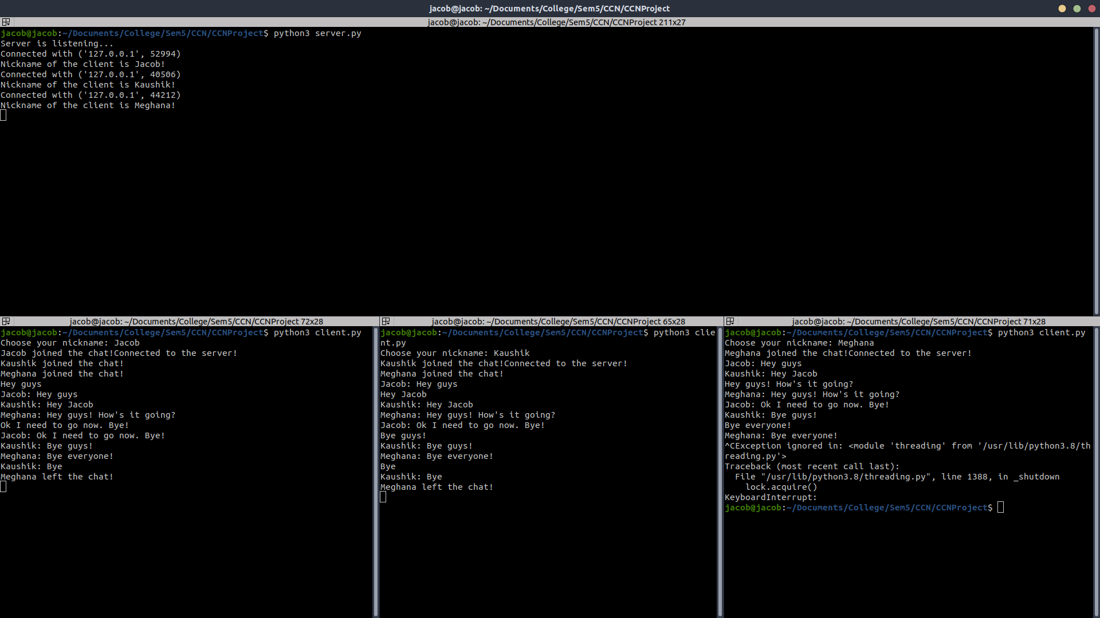

## **Conclusion**

We developed a chat room application in python using sockets and threads. This software is extremely light as is the bare concepts of how chatting systems like WhatsApp, Telegram and others work. Because of how light the system is, it is easy for anyone to join the chat if they are in the same network with a few steps. We learnt how TCP communication works and how to program sockets. We learnt also how to multithread our application so that it worked smoothly and we were able to add multiple users into the chat room.

## **References**

* <https://www.neuralnine.com/tcp-chat-in-python/>
* [https://www.ibm.com/docs/en/i/7.1?topic=communications-socket-programming](https://www.ibm.com/docs/en/i/7.1?topic=communications-socket-programming#:~:text=Socket%20programming%20shows%20how%20to,stand%2Dalone%20and%20network%20applications.)